*Mr.Vinay kumar*

* 1.**dir (directory) :-**  dir will show All The files & Folders in the location with details.

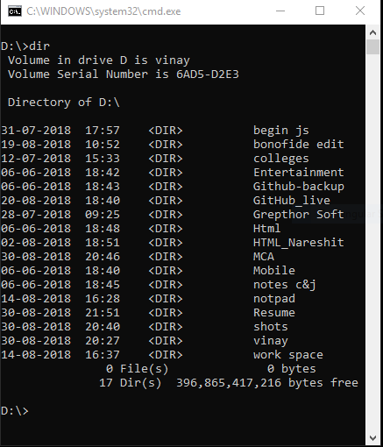

* 2 **dir/p (directory/page wise) :-** dir will show All The files & Folders display with details page wise.

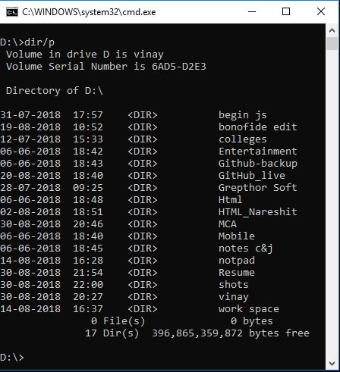

* 3.**dir/w(directory/window) :-** dir/w will show All The files & Folders names only

|  |  |
| --- | --- |
| /P | Page wise |
| /W | Width wise |
| /S | List of all files and directories of subdirectories |
| /AH | Display directories with hidden files |
| /AS | Display directory with system files |
| /AD | Display only directories present in current drive |

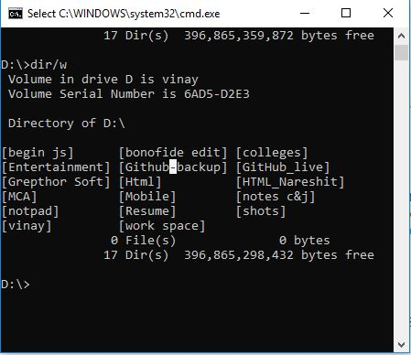

* 4 .**time :-** display the time based on user cpu time

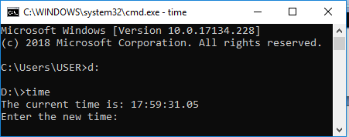

* 5. **Date *:*-** display the time based on user cpu date

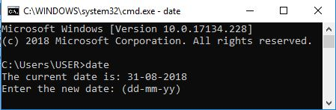

* 6.**Cls(clear screen):-** it clear the screen

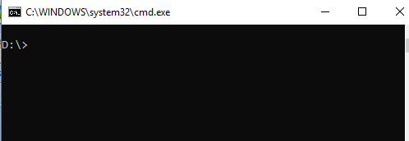

* 7.**Move :-** move the file from one location to another folder

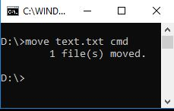

* 8.**ren :-** if you want to rename a file from existing file then use this cmd

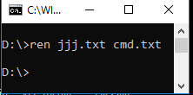

* 9.**Create Text File :-** this command is used to create a new text file ie ***copy con filename.txt***

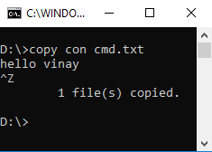

* 10.**Ver :-** this command will show version of window what kind of version we use

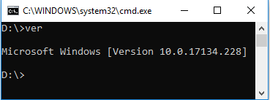

* 11.**CD(change directory) :-**  this command is used to change the directory **cd filename**

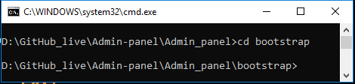

* 12.**Cd .. :-** this command is used to goes back one directory

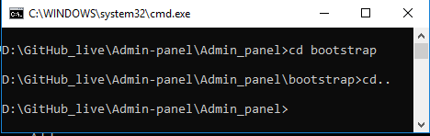

* 13.**Cd ../../../ :-** this command is used to goes back as depends on couple of dotes(..) **cd ../../**

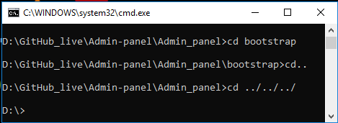

14.**batch file :-** this command is used to goes back as depends on couple of dotes(..)**Copy con file.bat**

vinay

vamshi

kiran

raghu^Z

to excute batchfile just type file name .

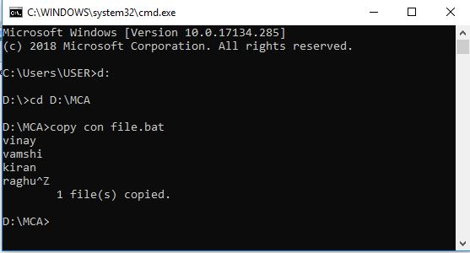

15.**batch file :-** Generally display the directory structure of a drive or path

**Syntax: C:\>Tree**

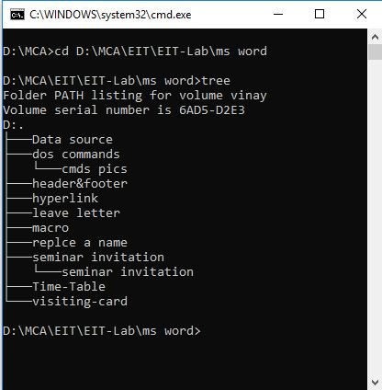

16. **Rd (Remove directory):-** This command is used to remove any directory from a disk

To remove directory the directory should be empty

**Syntax: d:\rd<Dirname>**

